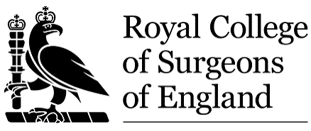
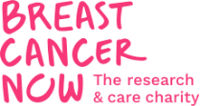

4th Breast Cancer Surgical Trials Day
The Library @ The Royal College of Surgeons, Friday 11th September 2026

10.00 Arrival, registration and coffee/breakfast in the library

10.30 Welcome Henry Cain/Shelley Potter

Session 1: ABS badged studies – How to get involved
Chair: Henry Cain

10.40 TADPOLE Shelley Potter
10.50 ATNEC Muskaan Khosla
11.00 HER2-RADiCAL Iain MacPherson
11.10 PRADA 2 Daniel Leff
11.20 LOLIPOP Shelley Potter
11.40 EndoNET Ramsey Cutress

Coming to a breast unit near you soon!
11.50 MAMMA-VAD Alona Courtney
12.00 ROSSINI Katherine Fairhurst
12.10 OPTIMA Young Rob Stein

12.20 Q&A

12.40 LUNCH AND NETWORKING

Session 2: How to improve study design for success
Chairs: Henry Cain/Katherine Fairhurst

1330 Co-designing trial interventions with patients: Linda Sharp
The SWEET study and other stories
1400 Research Project Development Workshop
1. Shoulder function after breast cancer Rebecca Wilson
2. The DISC (Ductal carcinoma In Situ Cavity shaving) study Sarah Tang
3. SPIO Dose De-escalation Feasibility Study (SPIO-DoDe) Tin Sein
4. Evaluating Personalised Prehabilitation in People with Early Ben Hood & Linda
Breast Cancer Receiving Neoadjuvant or Adjuvant Systemic Hogarth
Anti-Cancer Therapy: Building on the ACTIVATE Study
1445 COFFEE

1515 Presentation and feedback of study development All
& learning to the wider group

1545 SUMMARY & CLOSE Henry Cain/Shelley Potter

