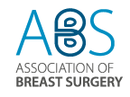 | 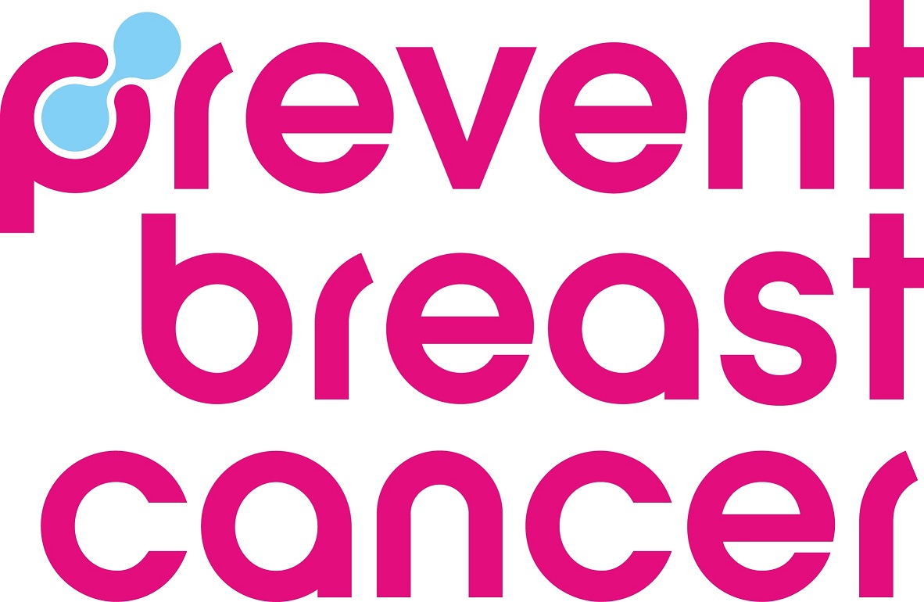
Association of Breast Surgery & Prevent Breast Cancer
Research Development Grants
Application Form

1. Personal details of the PI

Title of research proposal:

Surname:

Forenames (in full):

Title: | Male/ Female
Date of birth: | Nationality:
Current work address:

Contact phone number: | E-mail address:

2. Details of appointment

Title of current position:

When did you take up this appointment?

Name of institution:

Address for finance department, if different:

Finance officer responsible for the grant application:

Finance officer’s contact phone no: | Finance officer’s e-mail address:

3. Co-applicant details

Please name all co-applicants for this research (including job title/qualifications/description of contribution):

4. Declaration
I have read the details of the Association of Breast Surgery & Prevent Breast Cancer research grants and, if my application is successful, I agree to:

- Submit a brief report to the ABS & Prevent Breast Cancer six months into the research project and within 3 months of the conclusion of the project. This would be for the use of the ABS & Prevent Breast Cancer in both paper and electronic publications.
- To fulfil the reasonable media requests of ABS & Prevent Breast Cancer, including making a presentation of the project outcomes to the ABS Academic & Research Committee
- To notify the ABS & Prevent Breast Cancer of any changes to the project and of any publications resulting from the project

Signature of Applicant:

Date:

Applications should be saved as a pdf and returned to lenasebova@absgbi.org.uk by the 9th September 2024 at 5pm. Please submit the forms as a PDF named with the PI.

Please note that holders of a current ABS or ABS & Prevent Breast Cancer award as Chief Investigator cannot apply for a further concurrent award as CI.

5. The research

Please note references are not included in the word count.

5a. Title of research proposal:

5b. Summary of your research programme, including study design, methodology and how it would be delivered.
(750 words maximum)

5c. How would your research further the objectives of the Association of Breast Surgery?
(150 words maximum)

5d. Outline how your research would be of value to the NHS and would take appropriate account of the priorities, needs and realities of the NHS?
(300 words maximum)

5e. Outline proposed Patient and Public Involvement (PPI) in your research
(please review the following guidance for researchers on PPI; https://www.nihr.ac.uk/documents/ppi-patient-and-public-involvement-resources-for-applicants-to-nihr-research-programmes/23437):
(150 words maximum)

5f. Outline how funding of your current grant application would lead to future research or changes to current practice.
(300 words maximum)

- Prevent Breast Cancer award

Please tick the box and complete the section below if your application meets the criteria for a Prevent Breast Cancer grant and you would like to
be considered for this.

Please outline how this project meets with the aims of Prevent Breast Cancer – breast cancer prevention, screening and early diagnosis. Screening and early diagnosis covers a wide range of possibilities for a surgeon researcher, including imaging, biopsy techniques, localisation, surgery for screen-detected lesions, high risk patients, health inequalities, risk factors, public health and education.
This should include the following:

- How the project relates to the aims of Prevent Breast Cancer (www.preventbreastcancer.org.uk);
- How the project may in the future lead to improvements in cancer prevention, screening and early diagnosis if not directly addressed by the current project?
(150 words maximum)

- New Investigator & Nurse member awards

Please tick the box if, as the lead applicant, you are a New Investigator (no previous grants or awards as Chief Investigator (CI) or Principal
Investigator (PI)) and would like to be considered for the New Investigator
Award

Please tick the box, if as the lead applicant, you are an ABS Nurse Member and would like to be considered for a Nurse Member Award.

8. Lay summary

Description of the proposed research using clear terminology, which should be understandable to members of the general public.

This should include the following and should not exceed 100 words:
- A simple heading/ title
- Details of the area of breast disease it relates to and the proposed nature of the research
- How this research might deliver change and impact in the future

9. Financial details

Please note that grant funding should not normally be requested to support computer hardware, computer equipment, training or attendance at conferences or other events.

Financial details of the grant requested:
Item: | Amount:
 | Total:
Outline any other sources of funding for this project:

