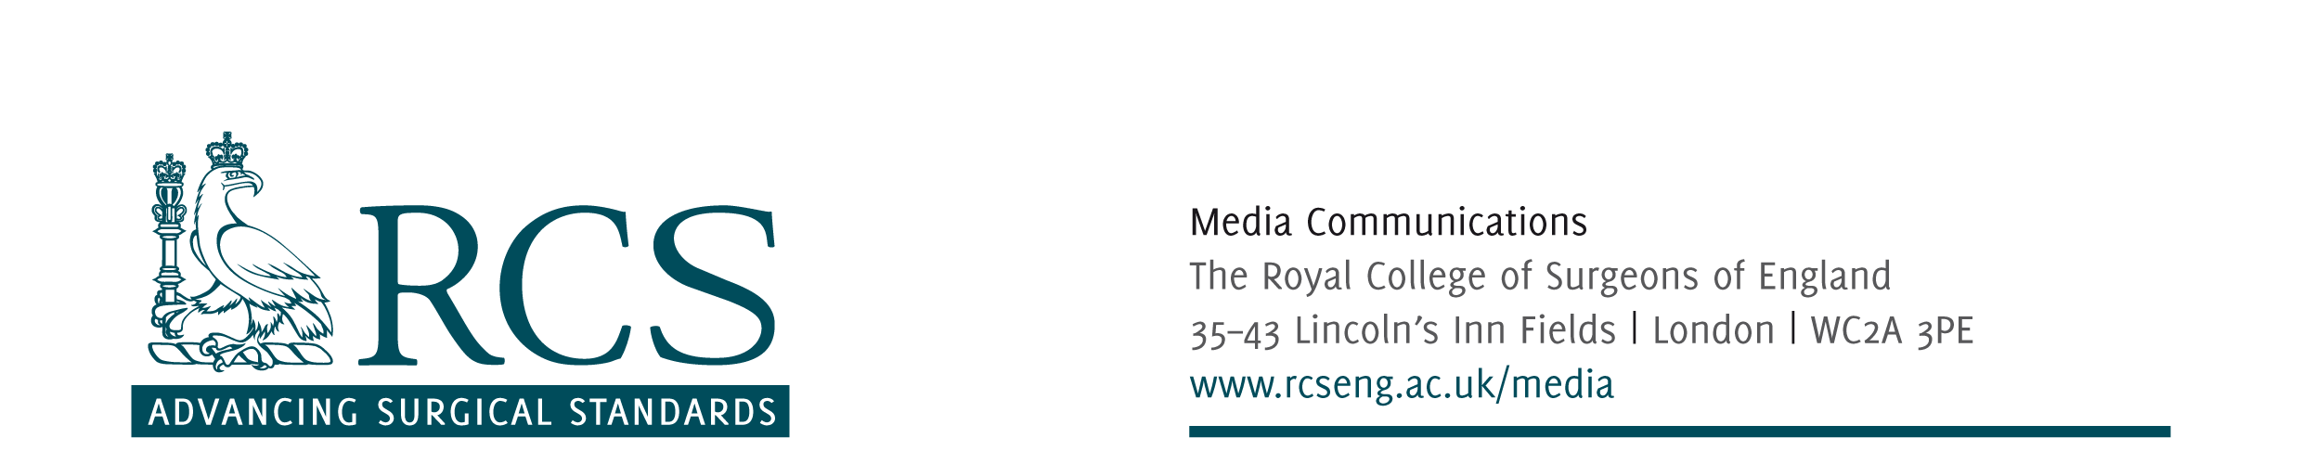
Friday, 06 January 2012
media release
Joint Surgical Statement on Government PIP breast implant announcement

The Association of Breast Surgery, British Association of Plastic and Reconstructive Surgeons, British Association of Aesthetic Plastic Surgeons, Federation of Surgical Speciality Associations and the Royal College of Surgeons have jointly agreed a response to the Government announcement today of support for patient who have received the PIP breast implant:
“'The news that all women who have received a PIP breast implant will be provided with support, and that all NHS patients will be offered monitoring, advice and remedial treatment if desired is welcome news. Surgeons’ organisations applaud those private cosmetic clinics who have committed to offer treatment to their patients free of charge and fully back the government call for the rest to follow suit. This situation raises again the need for better regulation and surveillance for all surgical implants and the surgical profession believes mandatory databases should be the next step – not least because this issue has exposed poor record keeping.”
In addition, the ABS add:
“The Association of Breast Surgery endorses the Secretary of State's clear recommendations for the management of women following breast reconstruction and augmentation with PIP implants. We will be working closely with the College, the Professional Associations and the Regulatory Authorities to ensure an orderly resolution to the current situation”
-ENDS-

Notes to editor:

If you have any queries please contact:
Matthew Worrall – Email: mworrall@rcseng.ac.uk; T: 020 7869 6047
Katie Bennett – Email: kbennett1@rcseng.ac.uk; T: 020 7869 6052
Out-of-hours: 07966 486 832

