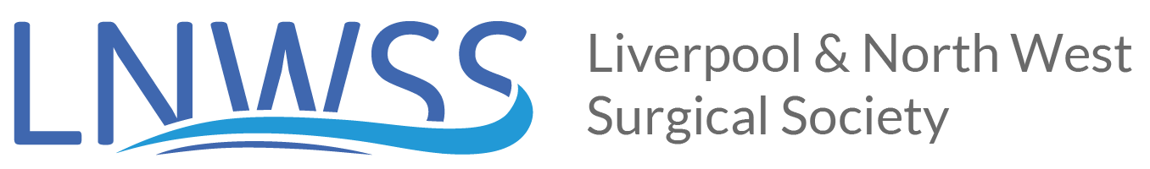

FIRST CALL FOR ABSTRACTS

Liverpool and North West Society of Surgeons Annual Meeting
Friday 6TH December 2019 Victoria Gallery & Museum, Ashton Street, Liverpool, L69 3DR

Abstracts are welcome from surgical trainees at all stages for the forthcoming meeting of the Society. This is a prime opportunity to make a significant regional presentation.

Abstracts need to be submitted electronically to dale.vimalachandran@nhs.net

Trainees may submit a maximum of two abstracts for consideration. Abstracts should be no longer than 300 words and the closing date for submissions is 12.00 (midday) Sunday 6th October 2019. Abstracts will be judged by the Society Committee during the week commencing Monday 7th October 2019, therefore any abstracts received after this date will not be considered.

When submitting your abstracts it is an essential requirement that you specify the following:

- Whether you are applying for the CST or HST sessions
- The Department and Hospital in which you completed the work
- The Consultant supporting your submission
- Please ensure that your name, title and current Hospital are clearly visible at the top of the abstract
Those presenting successful submissions will be required to register for and attend the meeting. Prize sessions will take place across the day, with judging taking place immediately afterwards.

The winner of the HST prize for the Will Lloyd Jones Tankard and the CST prize for the Sir Robert Shields Quaich will be announced at the end of the dinner in the evening. This year we are also delighted that the Association of Breast Surgeons are also kindly sponsoring a prize for the best Breast presentation across all 3 categories (poster, CST and HST).

The best abstracts not accepted for oral presentation will be accepted for posters for the award of the Roger Croton Shield.

Kind regards

Dale Vimalachandran
Society Secretary

