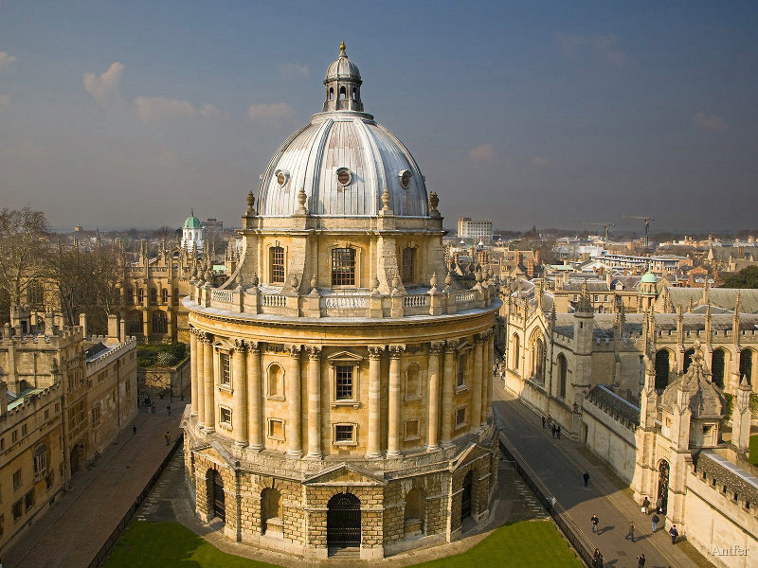

Oxford Oncoplastic Breast Surgery (OOPS) Course 2019

(21st-22nd Mar 2019)

A course focussing on breast conservation surgery; suitable for career breast surgery trainees (ST6-8), consultants, career grade breast surgeons, with highly reputed faculty.

Day-1: Therapeutic Mammoplasty & Breast Reduction

( 6 CPD Points – Approved by RCS England)

Day-2: Partial Breast Reconstruction (LICAP, TDAP, mini-LD)
(LIMITED SPACES)

Details of Programme to be confirmed.

Venue:Jury’s Inn, Oxford

Registration fee:
Day-1 only: £300
Day-2 only: £300 (UK Trainees), £400 for Consultants, Associate Specialists and overseas doctors
2-days: £500 (UK Trainees), £600 for Consultants, Associate Specialists and overseas doctors
(10% discount for UK Mammary Fold members)

Contact:
Lauren Janssen (Course Administrator)
E-mail: oopscourse@outlook.com

Payment due by 10th Dec to confirm a place on the course.
(Any cancellation up to 20th Jan 2019 would be subject to 20% cancellation fee.
No refund would be offered for cancellations after 20th jan 2019.)

