Trial Summary
Title: | ATNEC–Axillary management in T1‐3N1M0 breast cancer patients with FNA or core biopsy proven nodal metastases at presentation who convert to node negative after NEoadjuvant Chemotherapy
Rationale: | Axillary ultrasound, with fine needle aspiration (FNA) or core biopsy of suspicious lymph nodes, is used in the initial diagnostic work up of breast cancer patients to document nodal status and staging prior to treatment planning. Patients with FNA or core biopsy positive nodes are often referred for neoadjuvant chemotherapy (NACT) and it is currently the standard to perform axillary lymph node dissection (ALND) at the time of breast surgery after completion of NACT. ALND damages lymphatic drainage from the arm, and women may subsequently develop lymphoedema. As well as the discomfort of arm swelling this causes restricted shoulder movement, pain, numbness and other sensory problems. These adverse effects interfere with daily activities, are distressing, impair quality of life and are costly to the NHS in terms of rehabilitative treatments (such as physiotherapy and lymphoedema clinics), as they are often irreversible and symptom relief is difficult.  The performance of sentinel node biopsy (SNB) in patients who are node positive before NACT was tested in Z1071¹and SENTINA² trials. All patients underwent ALND following SNB. Z1071 showed that the success rate of SNB was 92.5%, 40% of patients had ypN0 disease, and the false‐negative rate (FNR) was 12.6%. The SENTINA study reported 80% success rate of SNB and the FNR was 14%. The FNR decreased when dual mapping agents were used and was less than 10% when ≥3 nodes were removed. Additionally, Z1071 suggested that clip placement at diagnosis of node‐positive disease with removal of the clipped node during SNB reduces the FNR of SNB³.  It has been demonstrated that NACT results in eradication of nodal disease in up to 40% of patients. Omission of additional axillary surgery in patients with a negative SNB after NACT appears to be logical however the recurrence and survival rates are unknown and there is a risk of under treatment. The next step is to determine in a randomised trial whether ALND can be omitted in these patients with no residual disease identified by SNB.
Eligibility Criteria: | - Age ≥ 18  - Male or female  - T1‐3N1M0 breast cancer at diagnosis (prior to the start of neoadjuvant chemotherapy (NACT)) by AJCC staging 7th edition  - FNA or core biopsy confirmed axillary nodal metastases at presentation (prior to NACT)  - Oestrogen receptor, progesterone receptor and HER2 status evaluated on primary tumour  - Received standard neoadjuvant chemotherapy as per local guidelines  - Ultrasound of the axilla at completion of neoadjuvant chemotherapy  - Undergo dual agent targeted sampling after NACT and at least 3 nodes should be removed  - No nodal metastases post NACT on axillary surgery  - Written informed consent for the study
Exclusion Criteria: | - Bilateral invasive breast cancer  - Sentinel node biopsy prior to neoadjuvant chemotherapy

- Previous axillary surgery on the same body side as the scheduled targeted sampling
- Radiation therapy for the currently diagnosed breast cancer prior to randomisation
- Previous cancer less than 5 years previously or concomitant malignancy except o basal or squamous cell carcinoma of the skin o in situ carcinoma of the cervix
  - in situ melanoma
  - contra‐ or ipsilateral in situ breast cancer
Objectives: | To assess whether axillary treatment can be omitted in patients with no residual positive nodes after NACT, without detriment to Invasive Disease‐Free Survival (IDFS)
Trial Design: | A multi‐centre phase III randomised clinical trial with non‐inferiority endpoint. There will an in‐built initial pilot phase to assess:  - Patient and clinician acceptability  - Identification rate and false negative rate of a) dual agent sampling, b) clipped/tattooed node  - Feasibility of tissue collection from primary tumour and positive node before and after neoadjuvant chemotherapy
Trial arms: | Randomisation  Experimental: No axillary treatment  Control: Axillary treatment (Axillary radiotherapy or axillary lymph node dissection)
No. patients: | 2700 patients o 1350 patients per arm  The 5‐year disease free survival for patients with node negative disease after neoadjuvant chemotherapy was estimated to be around 80% based on the pooled analysis published by von MG et al⁴. With improved outcome over time we would anticipate higher rates to be seen today and thus have assumed a 5% increase in the control arm rates. Assuming a minimum follow‐up of 5 years and the 5 year invasive disease free rate for the control arm patients is 85%, then we would need to randomise 1350 patients in each treatment arm (2700 in total) to have the ability to demonstrate non‐inferiority of test directed treatment, defining non‐inferiority as  ‘no worse than 3.5%’ below the control arm 5‐year invasive disease‐free survival  (IDFS) with a 5% one sided significance level and 85% power.
Stratification: | - Institution  - breast‐conserving surgery (BCS) or mastectomy  - receptor status (triple negative, HER2+, ER/PR+ and HER2‐) 4. pCR in breast (yes, no)
Outcome measures: | Primary outcomes:  - Invasive Disease‐Free Survival (IDFS)  Secondary outcomes:  - Arm morbidity and quality of life  - Local (breast or chest wall) recurrence  - Regional (nodal) recurrence  - Distant metastasis, overall survival  - Contralateral breast cancer  - Non‐breast malignancy  - Economic evaluation
Analysis: | The primary outcome of Invasive Disease‐Free Survival (IDFS), will include:  - Ipsilateral invasive breast tumour recurrence: invasive breast cancer involving the same breast parenchyma as the original primary  - Regional invasive breast cancer recurrence: Invasive breast cancer in the axilla, regional lymph nodes, chest wall, and skin of the ipsilateral breast  - Distant recurrence: Metastatic disease‐breast cancer that has either been biopsy confirmed or clinically diagnosed as recurrent invasive breast cancer  - Death attributable to any cause, including breast cancer, non‐breast cancer, or unknown cause  - Contralateral invasive breast cancer  - Second primary nonbreast invasive cancer  IDFS will be calculated from the date of randomisation to the date of first event or the censor date and assessed using Kaplan‐Meier curves and compared using Cox proportional hazards models after adjustment for stratification variables. The final analysis of the primary outcome measure will be undertaken when all patients have a median of 5 years follow‐up.

Trial Schema

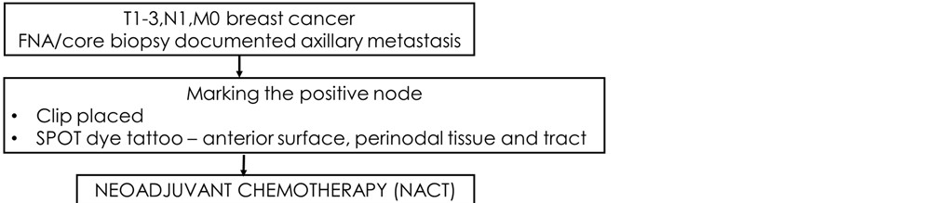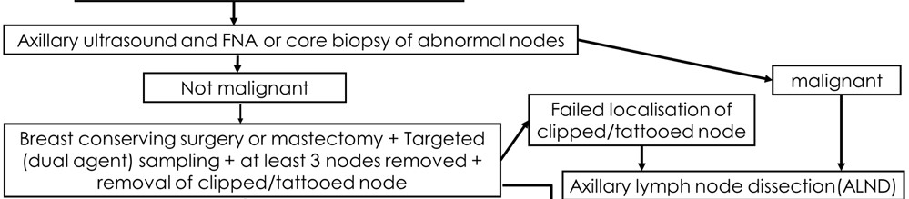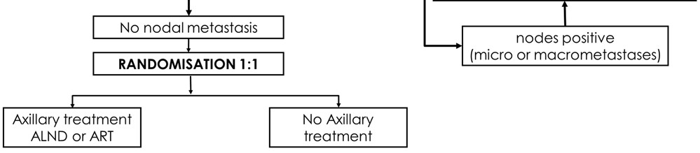

Tissue collection

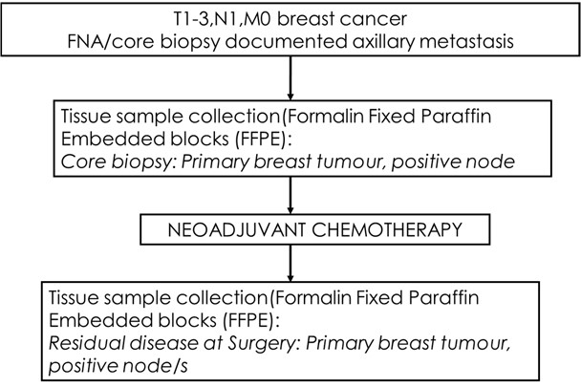

Reference List

- Boughey JC, Suman VJ, Mittendorf EA, Ahrendt GM, Wilke LG, Taback B et al. Sentinel lymph node surgery after neoadjuvant chemotherapy in patients with node‐positive breast cancer: the ACOSOG Z1071 (Alliance) clinical trial. JAMA 2013; 310(14):1455‐1461.
- Kuehn T, Bauerfeind I, Fehm T, Fleige B, Hausschild M, Helms G et al. Sentinel‐lymph‐node biopsy in patients with breast cancer before and after neoadjuvant chemotherapy (SENTINA): a prospective, multicentre cohort study. Lancet Oncol 2013; 14(7):609‐618.
- Boughey JC, Ballman KV, Le‐Petross HT, McCall LM, Mittendorf EA, Ahrendt GM et al. Identification and Resection of Clipped Node Decreases the False‐negative Rate of Sentinel Lymph Node Surgery in Patients Presenting With Node‐positive Breast Cancer (T0‐T4, N1‐N2) Who Receive Neoadjuvant Chemotherapy: Results From ACOSOG Z1071 (Alliance). Ann Surg 2016; 263(4):802‐807.
- von MG, Untch M, Blohmer JU, Costa SD, Eidtmann H, Fasching PA et al. Definition and impact of pathologic complete response on prognosis after neoadjuvant chemotherapy in various intrinsic breast cancer subtypes. J Clin Oncol 2012; 30(15):1796‐1804.

