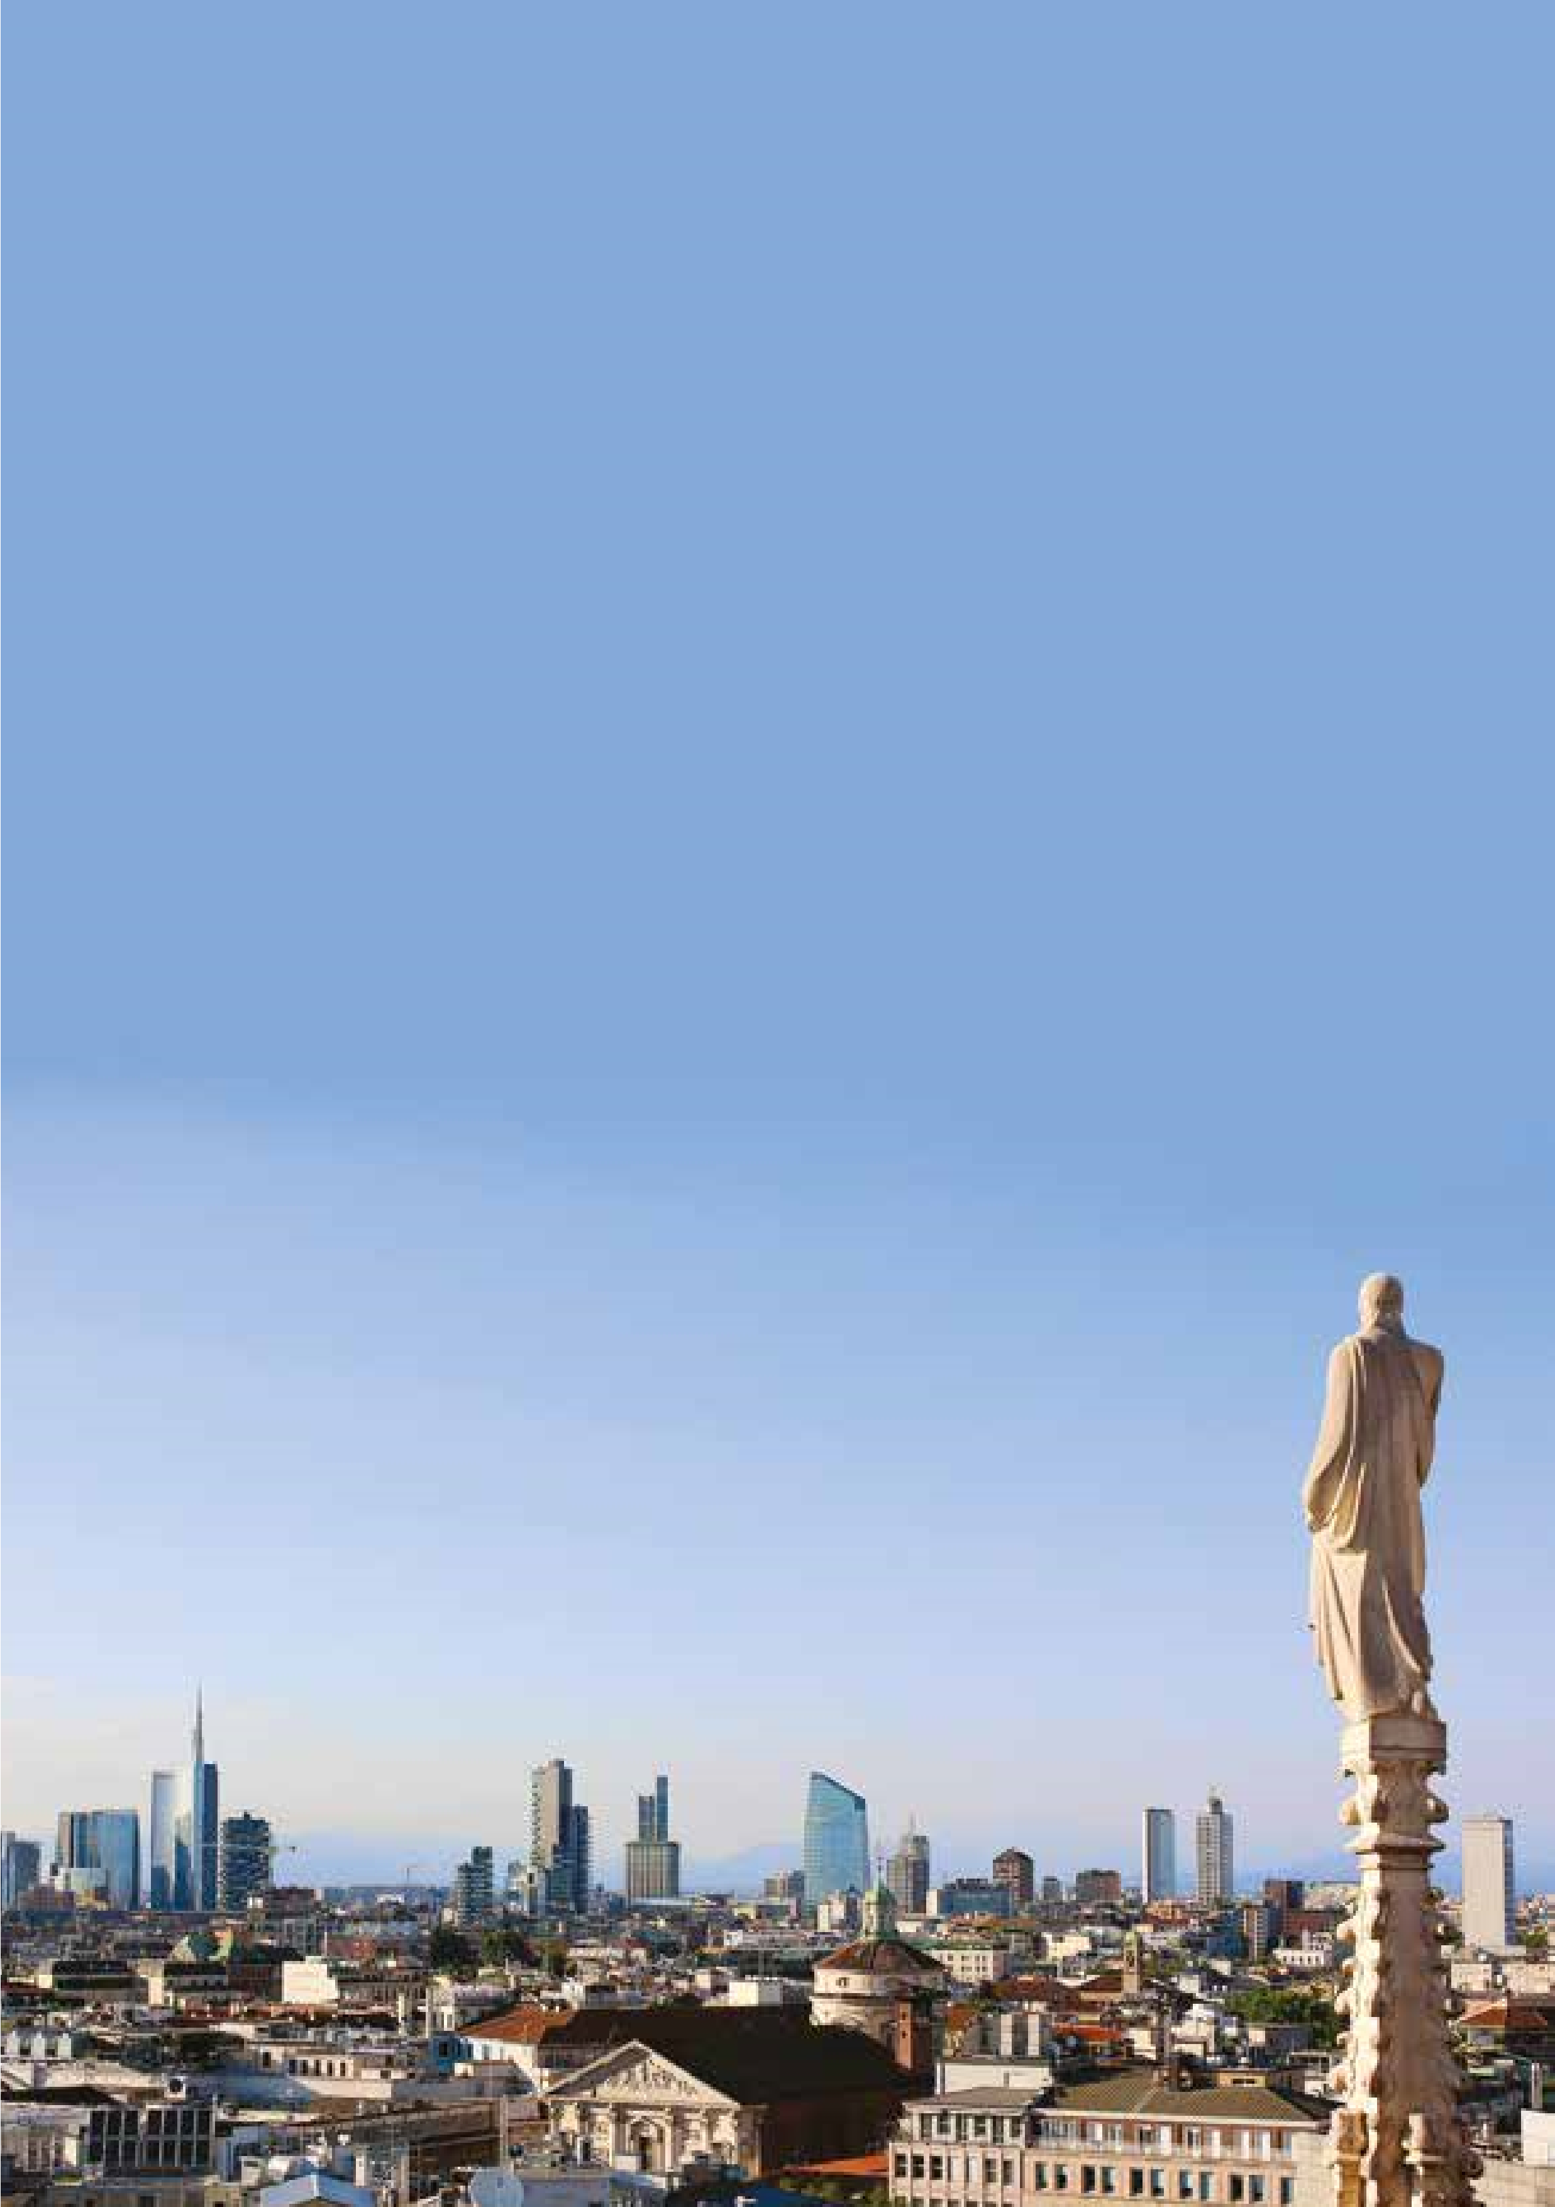
presents
ONCOPLASTIC BREAST MEETING
MILANO, 13
th
- 16
th
DECEMBER 2017
Conference Venue:
Milano
15.00/15.20
Biofilm and infection: which kind of prophylaxis?
(N. Petrosillo)

WEDNESDAY 13th DECEMBER 2017
08.00/11.00_Registration
10.50/11.00
OPENING AND CONFERENCE INTRODUCTION
PRE-CONFERENCE COURSES
Pre-conference Workshops
Pills of Oncoplastic Breast Surgery
(Chairman: A. Rancati)
11.00/11.30
Planning Oncoplastic Surgery: Past - Present - Future
(W. Audretsch)
11.30/11.55
Planning an implant based breast reconstruction: two stages and DTI (M. Brown)
11.55/12.20
Surgical procedures to improve the final outcome: two stages and DTI (video-lecture) (M. Nahebadian)
12.20/12.45
Planning an autologous flap and fat transplantation
- Andree)
12.45/13.10
Latissimus Dorsi surgical procedures (video-lecture)
- Hammond)
13.10/13.25
Q&A
(Discussant: A. Rancati)
Breast Reconstruction and Complications
(Chairman: M. Brown)
13.30/14.10
Bacterial Biofilm and breast implant infection, capsular contracture, late seromas and BIA-ALCL (M. Clemens)
14.10/14.35
Breast implant surgery: common complications in two stages and DTI: how to prevent and how to treat (A. Pusic)
14.35/15.00
Autologous Tissue Surgery: common complications in the use of flaps and fat: how to prevent and how to treat
programme
(C. Andree)
15.20/15.40
Recovering from poor outcome in Oncoplastic Surgery
(A. Rancati)
15.40/15.50
Q&A
(Discussant: M. Brown)

{ 15.50/16.30_Coffee break }
GUEST LECTURES
Introducer: M.B. Nava
16.30/17.00
Overdoing in breast surgery
(TBD)
17.00/17.30
Treatment of low-risk ductal carcinoma in situ
(J. Benson)
17.30/18.00
Neo-adjuvant pertuzumab and trastuzumab.
The Neo-Sphere: a multicenter randomized trial
(L. Gianni)
18.00/18.30
The evolution of implant-based breast reconstruction
(P. Cordeiro)
18.30/18.45
FELLOWSHIP G. QUERCI DELLA ROVERE LECTURE
(G. Querci della Rovere)
Introducer: (G. Catanuto)
18.45/18.55
CONFERENCE PRESIDENT GREETINGS

{ 19.00_Welcome Cocktail }
THURSDAY 14th DECEMBER 2017
SURGICAL ONCOLOGY SESSION
Breast conservation
(Chairman: M. Douek)
08.00/08.15
Surgical and patient-reported outcomes after therapeutic mammaplasties and wide local excision (J. Rusby)
08.15/08.30
Intraoperative ultrasound guidance in breast conserving surgery a randomized controlled trial (COBALT)
(M.P. Van den Tol)

08.30/08.45
Breast conservative treatment in association with implant
augmentation and intraoperative radiotherapy
(
P. Veronesi
)
08.45/09.00
Intraoperative assessment of margins
(
M. Douek
)
09.00/09.15
Q&A
(
Discussant
:

M. Douek)

09.15/09.40
KEYNOTE VIDEO-TEACHING LECTURE
How to reshape the breast after wide resection has been
performed in all the quadrants
R. De Vita
(
)
09.40/10.00
HOT-TOPIC LECTURE
Preoperative cryoablation-mediated tumor antigen presentation
and/or ipilimumab-mediated immune modulation in women with
operable breast cancer
)
(
V. Sacchini
10.00/10.30

Face to Face:
DTI Pre-Pectoral: clinic data on two different ADM
(
G. Berna - J. Murphy
)
{
10.30/11.00_Coffee break
}
Neoadjuvant systemic therapies

Chairman: L. Gianni
(
)
11.00/11.15

Primary systemic therapies
M. Harries
)
(
11.15/11.30
Breast conserving surgery after primary systemic therapies
(
)
M. Douek
11.30/11.45
Primary systemic therapies and axillary management:
the evidence
)
(
J. Benson
11.45/12.00
The breast boost after neoadjuvant chemotherapy
)
L. Lozza
(
12.00/12.15
Q&A
(
Discussants: L. Gianni - L. Lozza
)

12.15/12.40
KEYNOTE VIDEO-LECTURE
How to obtain “aesthetic” outcome in implant based breast
reconstruction: my vision
)
(
R. De Vita
12.40/13.00
HOT TOPIC LECTURE
Aesthetic breast surgery associated cancer: Breast
conservation - Conservative mastectomy
)
W. Audretsch
(
{
}
13.00/14.00_Lunch
14.00/14.20
KEYNOTE LECTURE
Immunotherapy for breast cancer: hope or hype?

M. De Laurentis
(
)
14.20/15.00
VIDEO TEACHING SESSION
Contra-lateral breast symmetrization
D. Hammond - A. Rancati
)
(
Conservative mastectomies and implant-based breast
reconstruction
(
)
Chairman: Z. Winters
15.00/15.15
NAC-sparing mastectomies. The Italian National Registry
)
L. Orzalesi
(
15.15/15.30
The Multi Centre Canadian Acellular Dermal Matrix Trial (MCCAT)
)
M. Brown
(
15.30/15.45
Alternatives to dermal matrices or autografts
(
S. Folli
)
15.45/16.00
Robotic surgery: real tool or momentary “fashion”
)
A. Toesca
(
16.00/16.10
Q&A
(
Discussants
:

N. Rocco - Z. Winters)
16.10/16.40_Coffee break
}
{
Evidence-Based Oncoplastic Breast Surgery

Chairman: N. Rocco
)
(
16.40/17.00
Evidence-Based Surgery
(
A. Thoma
)
17.00/17.15
Systematic reviews in surgery: Cochrane Collaboration Criteria
(
L. Moja
)
17.15/17.30
How to read a forrest plot in a meta-analysis: Relative risks,
odds ratios and confidence intervals
(
P. Chiodini
)
17.30/17.45
Cochrane systematic reviews: evidences in implant based
breast reconstruction
(
N. Rocco
)
10.05/10.20
Dual Plane and ADM (D. Hammond)
10.20/10.35
Dual plane and no meshes (A. Rancati)
10.35/10.45
Q&A
(Discussants: M. Brown - A. Rancati)

{ 10.45/11.15_Coffee break }
FAT ASSISTED KEYNOTE LECTURES
11.15/11.40

FRIDAY 15th DECEMBER 2017
Risk reduction surgery
(Chairman: J. Benson)
08.00/08.15
Genetic risk assessment (A. De Nicolo)
08.15/08.30
Contra-lateral mastectomy after breast cancer
(J. Benson)
08.30/08.45
Quality of life after risk reduction
(Z. Winters)
08.45/08.55
Q&A
(Discussants: C. Borreani - A. De Nicolo)
08.55/09.20
KEYNOTE LECTURES
The going flat choice: current reasons for rejecting reconstruction (C. Borreani)
Patients selection and personal thought for different
surgical procedures trough DTI (Chairman: M. Brown)
09.20/09.35
Epi-Pectoral breast reconstructions with ADM
(G. Allen)
17.45/17.55
Q&A
(Discussants: N. Rocco - A. Thoma)
17.55/18.35
KEYNOTE LECTURES
Systemic therapies and quality of life (TBD)
Breast cancer and nutrition: to prevent and to support (F. Berrino)
18.35/19.00
Live-simulation: Oncoplastic breast conserving surgery implant-based breast reconstruction surgical planning
(G. Catanuto - D. Hammond - A. Rancati)
09.35/09.50
Epi-pectoral breast reconstructions with synthetic mesh
(D. Casella)
09.50/10.05
Pre-Pectoral DTI for a painless post-operative recovery and natural aesthetic outcomes
(M. Salgarello)
Reproducible Volume Restoration and Efficient. Long-term volume retention after point-of-care standardized cell-enhanced fat grafting in breast surgery (R. Llull)
11.40/12.00
Bioengineered breast/hybrid breast: concept, technique and preliminary results (G. Allen)
12.00/12.20
How the fat cell transplantation change my surgical approach
(P. Blondeel)
12.20/13.00
Face to Face: Two stages VS DTI
(Chairmen: P. Cordeiro VS A. Rancati)

{ 13.00/14.00_Lunch }
Pearls on breast reconstruction: The NAC
14.00/14.15 Personal technique (D. Hammond)
14.15/14.30 External prosthetic NAC (A. Rancati)
14.30/14.45 Tattoo for NAC reconstruction (U. De Lucia)
14.45/15.05
HOT TOPIC LECTURE
Interaction between the implant surface and the human tissue and capsule formation (TBD)
15.05/15.45
“Young guns” meet the experts on Multi-Disciplinary-Team setting
(Chairman: G. Catanuto)
(Team: G. Bianchi - M.L. Carcangiu - M. Douek - S. Folli
M. Harries - L. Lozza)
15.45/16.00
Quality of Life after Breast Cancer Treatments (Chairman: Z. Winters)
Prevention and treatment of scars
(P. Ferrando)
16.00/16.15
Arm lymphedema treatment with abdominal flaps
(M. Salgarello)

16.15/16.30
Feasibility of cosmetic procedures in cancer patients:
when and what
(
A. Rancati
)

{
_
16.30/17.00
Coffee break }

Overdoing in Breast Cancer: the risks of over screening,
over-diagnosing and over-treating the disease
)
Chairman: A. Rancati
(
17.00/17.15

Breast screening guidelines: why recommendations differ and
what to do about it
(
K.J. Jorgensen
)
17.15/17.25
Over diagnosis in breast imaging
)
A. Evans
(
17.25/17.35
Over using chemotherapy in the adjuvant setting
(
TBD
)
17.35/17.45
Over irradiation

J. Jassem
(
)
17.45/17.55
Over using oncoplastic-surgery in breast cancer
)
G. Catanuto
(
17.55/18.10
Q&A
(
:
Discussants

A. Rancati - N. Rocco)

18.10/18.35
KEYNOTE LECTURE
Do we really know and are we really in control of our
decisions?
)
G. Pravettoni
(
18.35/19.00
KEYNOTE LECTURE
Quality of life after breast reconstruction and adjuvant treatments
Z. Winters
(
)
SATURDAY
16
th
DECEMBER 2017
CONSENSUS CONFERENCE
RADIOTHERAPY AND BREAST RECONSTRUCTION
Chairmen: M.B. Nava - A. Spano
)
(
Pre-Consensus LECTURES
08.00/08.20

RT and reconstruction
J. Jassem
)
(
08.20/08.40

Should immediate autologous breast reconstruction be
considered in women who require post mastectomy radiation
therapy? A prospective analysis of outcomes

(
A. Pusic
)
08.40/09.05

Tailored radiation therapy for breast cancer
)
(
R. Orecchia

09.05/09.15

Implant based breast reconstruction in radio-treated patients:
personal experience

)
P. Cordeiro
(

09.15/09.35

Radiotherapy and soft tissue breast reconstruction:
from flaps to fat
)
P. Blondeel
(
09.35/09.55

Pre-surgical radio therapy (PRT i.e. “neo-adjuvant”) and
post-radiation reconstruction: Planning and Techniques
(
W. Audretsch
)
10.00/12.00

DEABATES ON RADIOTHERAPY AND BREAST
RECONSTRUCTION
(
)
M.B. Nava - N. Rocco
INVITED SPEAKERS:
G. Allen - W. Audretsch - P. Blondeel - M. Brown
G. Catanuto - M. Clemens - P. Cordeiro
R. De Vita - D. Hammond - J. Jassem - L. Lozza
R. Orecchia - A. Pusic - A. Spano - Z. Winters
12.00/12.15

Doses distribution after expander insertion
)
L. Lozza
(
12.15/12.30

Does radiotherapy affect implant integrity?
)
S. Farè
(
12.30/13.00
CONSENSUS CONFERENCE - CONCLUSIONS
Consensus Paper Chairmen:
(
M.B. Nava - A. Rancati - N. Rocco)
13.00/13.30

MASTER LECTURE

(
M.B. Nava
)
13.30/13.45

CLOSING AND REMARKS

13.45
Farewell Lunch
