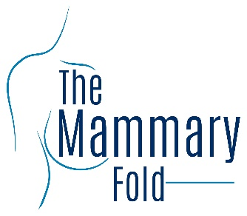
Regional Representatives Application Form

Role Advertisement:
Regional Representatives
Send application form to:
Themammaryfold
@gmail.com
before
26th October 2020

Roles and Responsibilities

Regional representatives of the Mammary Fold are sought to promote the work of the Mammary Fold to trainees within their region. The representatives will provide a local point of contact with the Mammary Fold to encourage participation.
The role can be divided into responsibilities to council and responsibilities to local trainees.
Responsibilities to Committee
Promote membership of the work undertaken by the Mammary Fold.
Provide feedback to the committee about the issues arising in their region with regard to training and development.
Contribution to the Annual General Meeting by helping with exhibitions, meeting guests, judging abstracts, raising sponsorship.
Availability to take on further roles within the organisation.
Regional representatives will not attend the Committee meetings.
Responsibilities to Local Trainees
The representatives will represent the Mammary Fold members with regards to all issues arising with their training either locally, regionally or nationally.
Representatives will be expected to liaise with the senior representative of the Mammary Fold and bring to their attention issues for resolution.
Representatives will act as a champion to the regional medical schools.
All representatives will be expected to arrange at least one teaching session for their local trainees during their tenure. This can be done with neighbouring regions if needed as some regions have small numbers of trainees.

In addition to the above responsibilities, there will be the offer of support for any local or regional teaching events or trainees meetings that are organised to:
Provide extra learning opportunities.
Consolidate trainees’ training issues.
Promote the work of the Mammary Fold.

Regions

We have 17 regions represented by regional representatives. The successful applicant stays in post for up to 2 years. Vacant regions up for elective this year are highlighted in pink below:

East of England
East Midlands (including Trent)
KSS
North London
South London/ South East
Mersey
North East
Northern Ireland
North West
Oxford
Scotland
Southwest: Peninsula
Southwest: Severn
Wales
West Midlands
Wessex
Yorkshire (including Yorkshire deanery and South Yorkshire and Humber)

To register your interest, please complete the application form below.

Role Advertisement:
Regional Representatives
Send application form to:
themammaryfold@gmail.com
before
26th October 2020

Application form for Regional
Representatives of the Mammary Fold
Please complete this form and address it to themammaryfold.com with the subject ‘’Regional representative application’’.

Name:

Email address:

Grade:
Plastics trainee General Surgery trainee

Hospital:

Deanery:

Previous organisational roles:

Ideas for regional collaborative events:

Appointments will be for two years. Please complete and return by 26th October 2020. Thank you. Voting will begin in November 2020 and the successful applicants will be announced at the December Mammary Fold Webinar.

