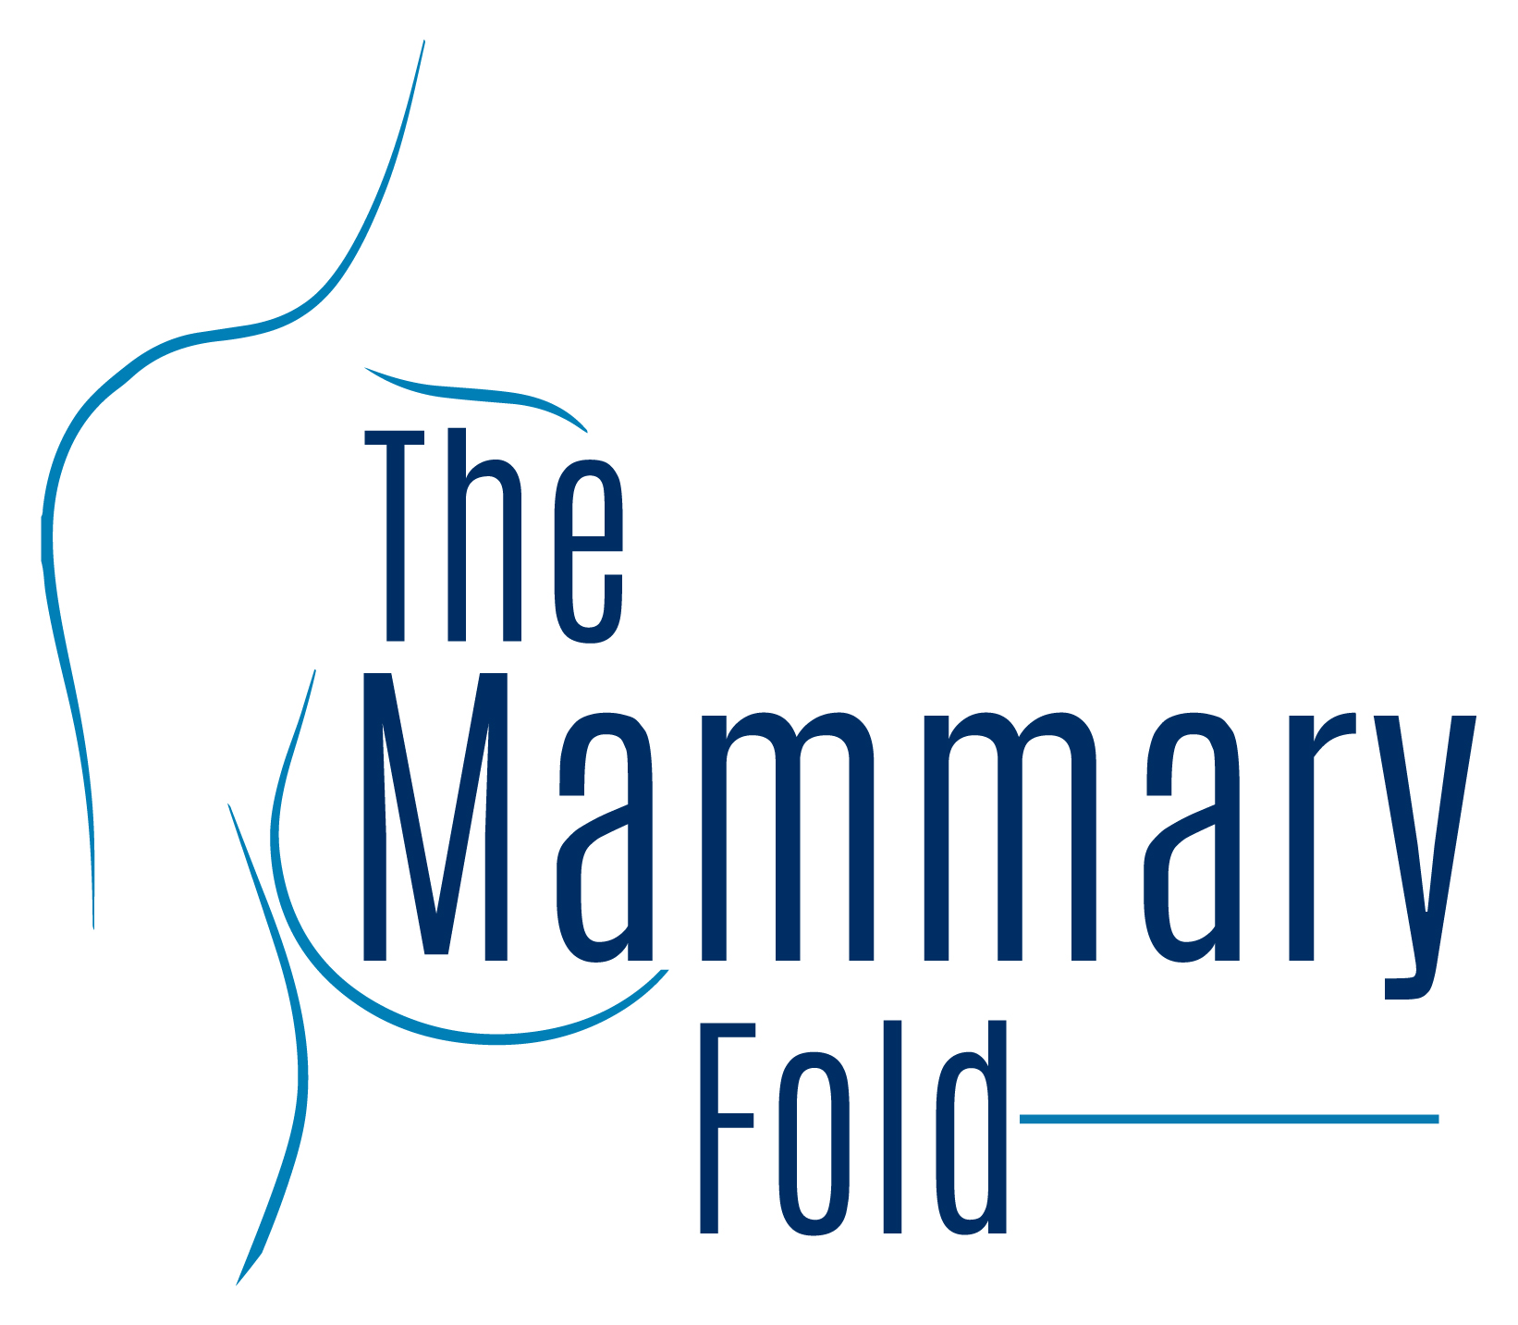
Mammary Fold Committee Job Descriptions for elections 2020-2021

Posts available for 2020/21

Treasurer OPEN FOR NOMINATIONS FOR 2020/21
The position of treasurer is responsible in maintaining the Mammary Fold Budget. ABS manages the account on behalf of the Mammary Fold, however the treasurer must provide detailed expenditure for all proposed events on a 6 monthly basis. All costs for events must be agreed by the ABS trustees. It is mandatory that the treasurer prepares a quarterly financial report to the ABS Association Manager. In addition the treasurer’s role is to raise funds from an established list of contacts to help cover the costs for the range of Mammary Fold educational events for the calendar year. The treasurer will be handed over a list of potential sponsors who are familiar and previously supportive of the Mammary Fold’s activities, though the task of raising funds is usually distributed among the committee and ordinary members. At the end of the fiscal year, a financial statement should be issued to keep members informed.
Secretary OPEN FOR NOMINATIONS FOR 2020/21
The main role of the Mammary Fold secretary is to coordinate committee meetings and teleconferences. You will be required to collate emails and format meeting agendas and compose the minutes. In addition you will manage the Mammary Fold email account for all the enquiries that come into the committee and distribute to the appropriate member.

It is an interesting role that facilitates and improves educational and political insight towards a career in breast and oncoplastic surgery. Whilst the role is involving it is not overly taxing due to there being sufficient time between tasks and is suited to any level of trainee.

Senior Representative OPEN FOR NOMINATIONS FOR 2020/21
The Senior Representative on the Mammary Fold Committee is a post for trainees in their final 2 years of training. The role of the representative is two-fold. The first role is to act as a liaison between senior breast trainees/consultants and the Mammary Fold Committee, and to feed back any training / teaching issues that can then be raised at national committee meetings. The second is to provide support and co-ordinate the regional representatives. The senior representative will be the point of contact for the regional representatives and will therefore have vital role in identification of any regional issues related to breast surgery training, and encourage regional representatives to deliver educational events related to breast surgery and ensure breast surgery trainees in each region are identified. As a Committee member you will attend the Mammary Fold teleconferences, and the Senior representative will also provide support with regards to the applications for the Regional representative posts and help with the shortlisting.

It is a rewarding role, and is a good starting point for developing your managerial and leadership skills.

Junior Representative OPEN FOR NOMINATIONS FOR 2020/21

Junior representative will represent trainees interested in breast surgery who are ST5 and below, including core trainees as well as Foundation Year 2 trainees. The main role is to encourage new breast trainees to join The Mammary Fold and express their views. Junior representative is expected to join the teleconferences of the Mammary Fold committee. Helping other committee members in their roles and assisting with organising the mammary fold educational events would be the other roles. Junior representative role is fun and not too onerous. It builds up team working and leadership skills and helps promote the Mammary Fold.

Other posts (for your information)

Chair of Mammary Fold NOT OPEN FOR NOMINATIONS FOR 2020/21
This is a busy but extremely fulfilling post suitable for a senior breast trainee in the last 3 years of their training. The role involves close liaison with Association of Breast Surgery (ABS) and requires attendance at the quarterly ABS clinical practice and standards committee meetings where trainees’ opinions can be voiced to the council members.

The Chair also oversees committee meetings every month by telephone conference. Responsibility is taken for the overall organisation of all educational events. In addition the Chair produces a report for the ABS yearbook, and chairs the Mammary Fold Session and AGM at the annual ABS conference.

The role requires a dynamic and organized individual, who is willing to approach the year with enthusiasm and determination. You will be in the privileged position of interacting with a diverse range of trainees and senior clinicians. The management and leadership experience gained will be essential skills for your future career.

Vice Chair of Mammary Fold NOT OPEN FOR NOMINATIONS FOR 2020/21

This role of the Vice Chair is mainly to support the chair and the other committee members in their roles.

Most importantly the Vice chair is responsible for the quarterly newsletter that is sent to the members to update them on the important events, courses and career opportunities. Though there are no other fixed committee meetings to attend, the VC might need to stand in for other members if they cannot attend the meetings especially the ABS council meeting, the Education and Training Committee Meeting of the ABS or the ASiT meeting. The VC will also work alongside the Education and training Representative to organise and chair the pre-ABS meeting.

The role requires a dynamic individual who will take an active part in many aspect of the Mammary Fold as you might be involved in attending meetings and arranging educational events and will be in the privileged position of interacting with a diverse range of trainees and consultants.

Education and Training Representative NOT OPEN FOR NOMINATIONS FOR 2020/21
The Education and Training (E&T) representative is a post suitable for senior breast trainee in the last 3 years of training. The main role of the post is to act as a point of contact for breast trainees. You have to be a source of information and advice on training issues, help where trainees have problems with training within their region, and to take these concerns to the Association of Breast Surgeons Education and Training Committee.

The E&T representative is expected to attend the quarterly meeting of the ABS E&T committee at the College. At this meeting the representative will provide an update on the activities of the Mammary Fold, raise the concerns of trainees and comment of the items on the agenda that may have an impact on trainees. These meeting give you an insight into the future of Breast Training and the committee values the trainee representative’s opinion.

The representative also has a key role in organising the various MF national educational events. This will include promotion of events, the administration of registration, helping in the organisation of logistics, speakers and programs and raising commercial sponsorship for the events.

Academic Representative NOT OPEN FOR NOMINATIONS FOR 2020/21

In 2014, the Mammary Fold Academic Collaborative (MFAC) was formed with the aim of promoting trainee-led audit and research at a national level. The Academic representative will be the Lead of the MFAC and act as the link between the Mammary Fold Committee and the MFAC. We are looking for a dynamic, motivated and inspiring person to take on that role. Due to the nature of the post, an academic background is preferred.

The post involves participation at the Mammary Fold telephone conferences and similar organisation of the MFAC telephone conferences. In addition, the role involves representing the trainees at the quarterly ABS Academic and Research Committee meetings and acting as a link between the groups. This is an excellent opportunity to improve the networks within groups interested in breast surgery research. The academic representative will play a vital role in co-ordination of the current MFAC committee to ensure continual delivery of trainee-led collaborative studies in breast disease. Furthermore, the role will involve organising the annual Mammary Fold Academic and Research day which has been successful in showcasing trainee-led collaborative studies in breast disease.

ASiT Representative NOT OPEN FOR NOMINATIONS FOR 2020/21

The role of ASiT rep is a stimulating and rewarding one with active participation as committee member of both Mammary Fold and ASiT. Mammary Fold commitments include devising and supporting committee initiatives and ensuring committee are appraised of ASiT activity and trainee issues raised and highlighted by ASiT.

Communication with committee will include regular reports on ASiT committee discussions and publications as well as regular telephone conferences. ASiT committee responsibilities include ensuring the views of breast trainees are represented at council as well as support all ASiT activity including the national conference, training courses and publications. There are bimonthly ASiT committee meetings at the Royal College of Surgeons (Eng) with quite a lot discussed and so you really need to read all the material sent to compliment the agenda.

The role is an excellent opportunity to further develop management and leadership skills and gain a real understanding of the political landscape of surgical training.

Social media Representative NOT OPEN FOR NOMINATIONS FOR 2020/21

The role of the Social media rep is to coincludes being a committee member of the Mammary fold and maintaining and updating the website in conjunction with the ABS communications co-ordinator. The representative will work closely with the ABS communications co-ordinator to ensure the website provides trainees with valuable and up to date information to enhance their training experience.

Being a committee member involves attending regular telephone conference meetings, organising and supporting educational meetings, MF educational events and annual general meetings (AGM) for MF.

Website maintenance and release of social media posts includes regular:
-upload of courses, conferences, meetings, etc
-upload of job advertisements related to breast surgery/oncoplastic surgery at all levels
-upload of important educational documents, guidelines, videos, etc
the role will work closely with the Vice chair and Educational and Training rep to collate this information and complement the complement newsletter.

The aim of the website, facebook page and twitter profile is to provide a source of up to date information relating to breast surgery, including conferences, courses, jobs, guidelines, FRCS revision and oncoplastic fellowship information. Enthusiasm and organisation skills are essential. You do not need to have and website experience but a sound knowledge of the use of social media platforms is essential.

