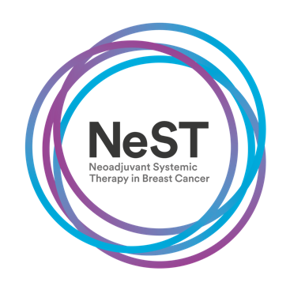

Neoadjuvant Systemic Therapy in Breast Cancer
A prospective, multicenter national audit

Launch Meeting
The Studio
7 Cannon Street, Birmingham

Monday 30th October, 12.00 noon - 5pm

Please complete in block capitals:

Title: _____________________________________________

Name: _____________________________________________

Job title: _____________________________________________

Work Address: _____________________________________________

Telephone number: _____________________________________________

E-mail address: _____________________________________________

I would like lunch: YES/NO

Any dietary requirements? _____________________________________________

PLEASE RETURN THIS FORM TO nestbcstudy@gmail.com by FRIDAY 20TH OCTOBER

