Programme for Mammary Fold pre-ABS Conference Education Day
Sunday 14th May
Ulster Hall, Belfast

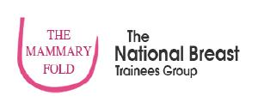

1pm AGM (outgoing and incoming committee)

2:00pm Prof Roy Spence: FRCS Exam
2:20pm Stuart McIntosh: Neo-adjuvant Chemotherapy
2:40pm Cliona Kirwan: San Antonio update part 1

3:10-3:40pm Coffee break

3:40pm Cliona Kirwan: San Antonio update part 2
4:10pm Stephen Kirk: Medico-legal issues
4:30pm Laura Johnson: ALCL update

4:50-5:10pm Coffee break

5:10pm James Harvey: Innovations in Breast Surgery
5:40pm Werbena Hamilton-Burke: TIG Fellowship Curriculum

6pm ABS Drinks reception

8pm Mammary Fold annual dinner

